|  |
| --- |
|  |
|  |
| **Website Check List 2.0** |
| March 26, 2012 |
| This is not a completed Check List |

|  |
| --- |
|  |

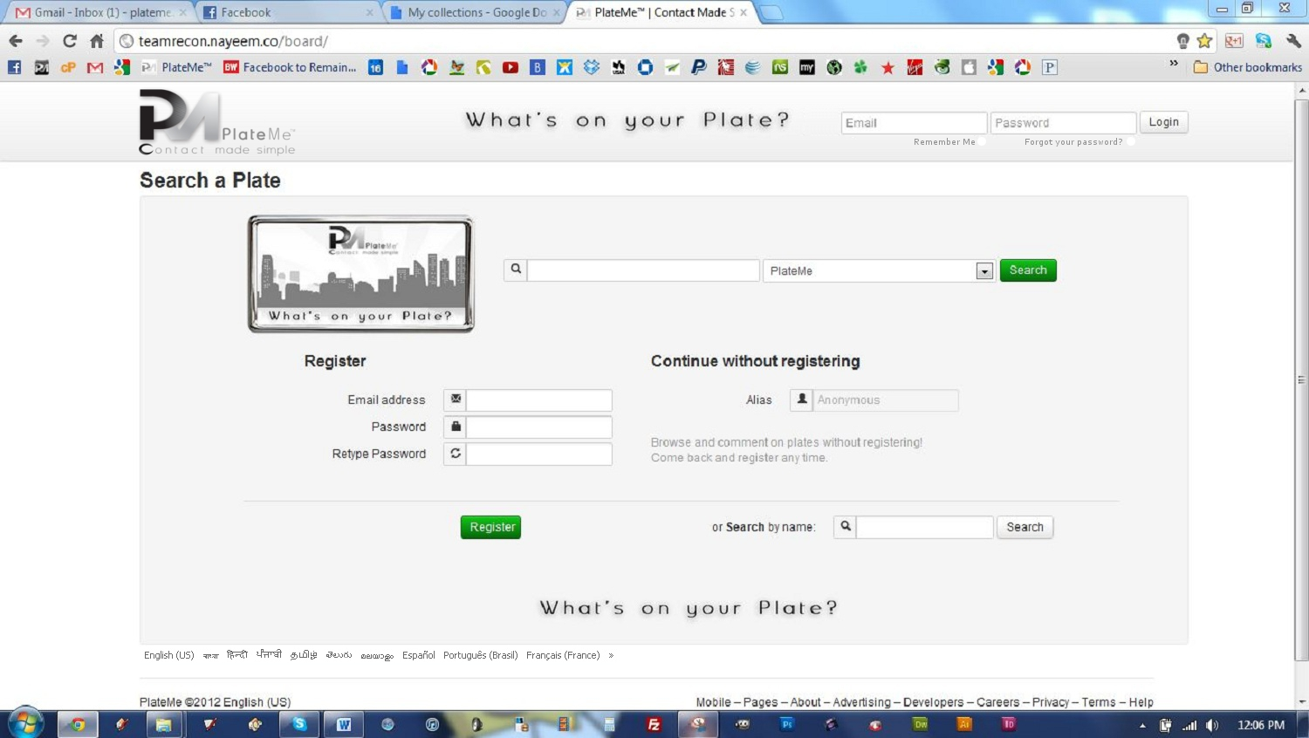

**Landing Page**

1. Insert Languages option (15)
2. Remember Me
   1. When this button is clicked the website will remember this user and the landing page will be skipped each time shooting the user to their profile page.
   2. Once the user manually logs out, the landing page will be accessible again.
3. Forgot Password
   1. Have the password sent to the users email address.
4. Make all buttons and functions work properly.
5. Search by Name must function properly
6. When user clicks “Anonymous Button” they should be routed to a generic profile page with a register now link as shown on the page below.
7. Allow Users to Register a License Plate from this page
8. Allow users to Register a Generic Plate from this page

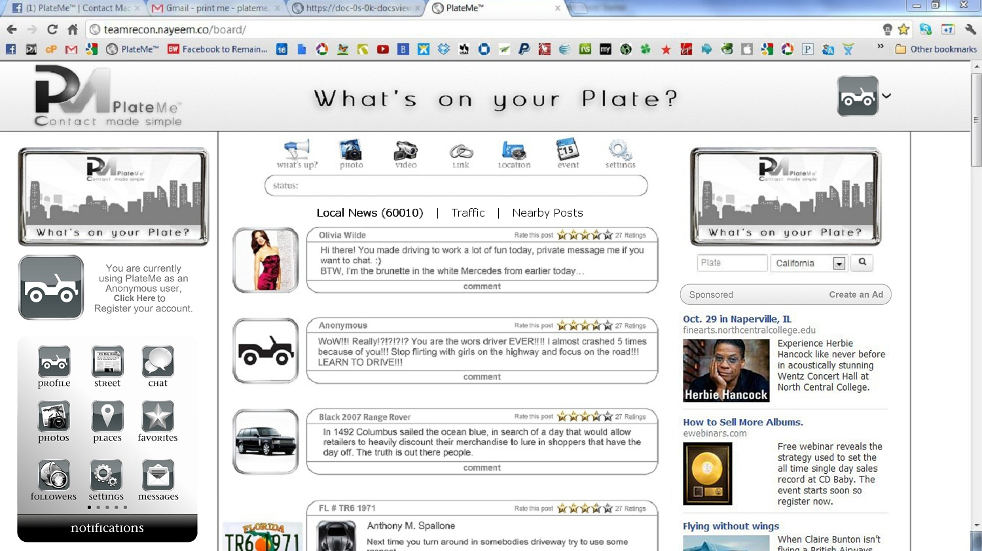**Anonymous Page**

1. Anonymous Page should look and feel like a registered profile when the anonymous user tries to perform certain functions like messages, chat, etc. a pop up should state, “Please Register now to perform this function.”
   1. Register Now should be highlighted in Blue and allow the user a 1 click access point to register.
2. News Feed
   1. Local News is news based on a specific zip code
      1. The local news can be posted by people who make a post and click, “Post as News”.
      2. Traffic, will be local traffic pulled from Google maps traffic
      3. Nearby Posts are posts based off a Zip Code and made “Public” by the user

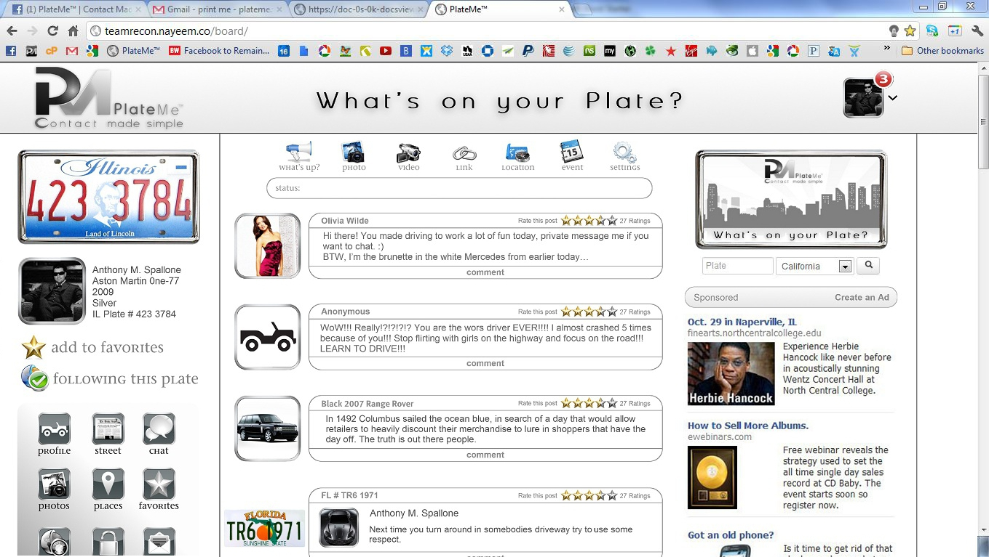**Profile Page**

1. The Profile Page should look “Identical” a trace over of the page above. All sizes and dimensions must look as they do above.
2. All features and functions on the left side bar should work:

|  |  |
| --- | --- |
| 1. License Plate with Plate Number should be identical to the actual license plate and plate number 2. All profile pictures should be squared off and within the chrome frame as it appears above 3. Add Favorites should work and function 4. Follow this Plate should work and function 5. Profile should bring you to profile 6. What’s Sup should bring you to News feed with all types of news. | 1. Chat should open chat and function properly 2. Photos should open albums and pictures of you 3. Places should open maps 4. Favorites should open favorites with search optimization 5. Followers should open followers with search optimization 6. Privacy should be changed to settings and open account settings 7. Mail should open messages |

1. All features and functions in the center column status bar should work:

|  |  |
| --- | --- |
| 1. Status Bar should appear as it does above    1. Once the status bar is clicked a post button should appear to allow user to post 2. Photo Button should allow users to post a photo to    1. The current wall    2. Add to album    3. To a friend’s wall    4. To multiple walls 3. Video Button should allow users to post a video to    1. The current wall    2. Add to album    3. To a friend’s wall    4. To multiple walls | 1. Link Button should allow users to post a link to    1. The current wall    2. To a friend’s wall    3. To multiple walls 2. Locations should open maps 3. Events should be renamed to Time Machine that when clicked allows    1. users to create events    2. update their calendar    3. navigate through the past easily    4. make future posts 4. Settings acts a drop down that allows the users to select post type:    1. Post as Me    2. Post as Anonymous    3. Post as News Story    4. Post as Traffic Update    5. Post in the Future    6. Post as Coupon |

1. All features and functions in the center column News Feed should work:

|  |  |
| --- | --- |
| 1. All photos in frames 2. Name | Plate Number 3. Star Rating with number of ratings    1. Click the rating to see who rated    2. Click their photo to go to their page 4. Time Stamp | 1. When comment is hit the user should have all the same features and functions as they do with the status bar    1. Photo    2. Video    3. Link    4. Location    5. Time Machine    6. Post As |

1. All features and functions in the right column should work:

|  |  |
| --- | --- |
| 1. Search    1. Use IP address to set default plate    2. Instant Photo Manipulation upon search    3. Shoot to search results page if there are multiple possibilities. | 1. Advertising    1. Make ads work properly.    2. Allow Create an Ad |

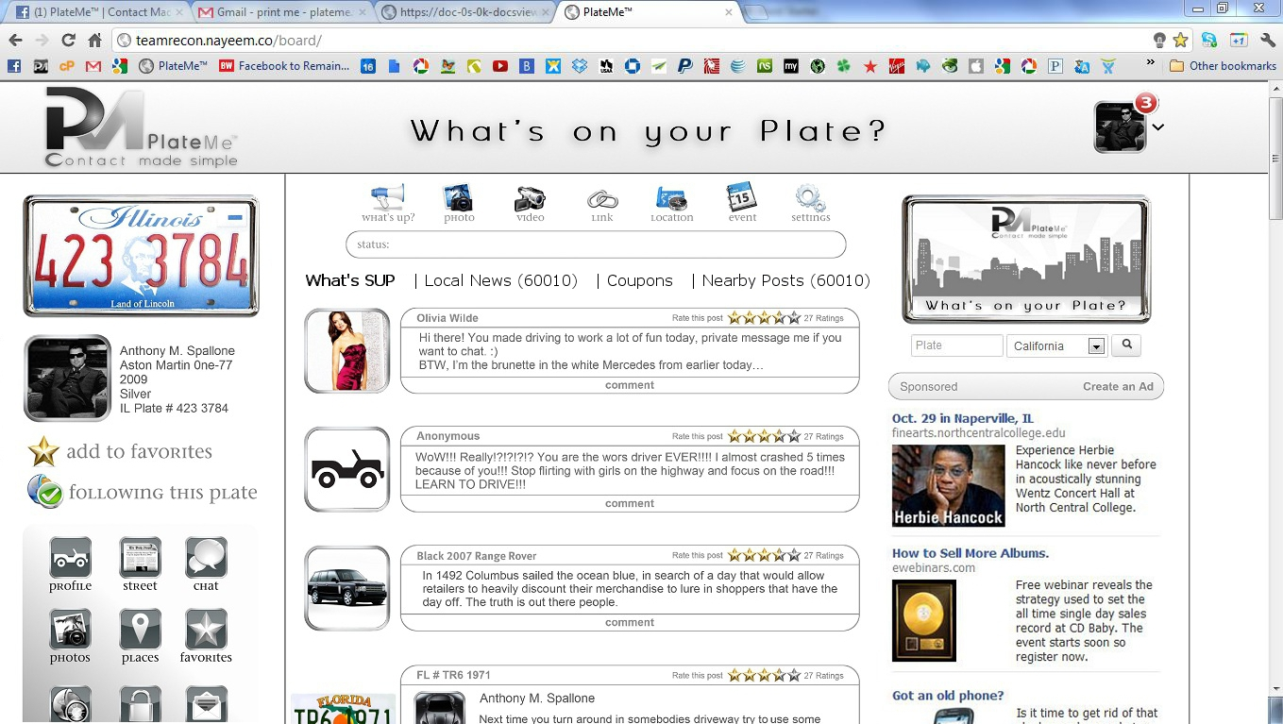**News Feed Page**

The News Feed should look “Identical” a trace over of the page above. All sizes and dimensions must look as they do above.

There are 4 News Feed Types:

1. What’s Sup
   1. This news feature shows all posts made by Favorites & Following (People you are following)
2. Local News
   1. This news feature shows all news posts made within a zip code
      1. When a user makes a post they have the option to “Post as News” these posts will appear within a specific radius.
3. Coupons
   1. Coupons can be listed by verified business only. When the coupons expire they must be automatically deleted from this page.
4. Nearby Posts
   1. These are posts made be all PlateMe users within a given zip code that allow their post to be public.

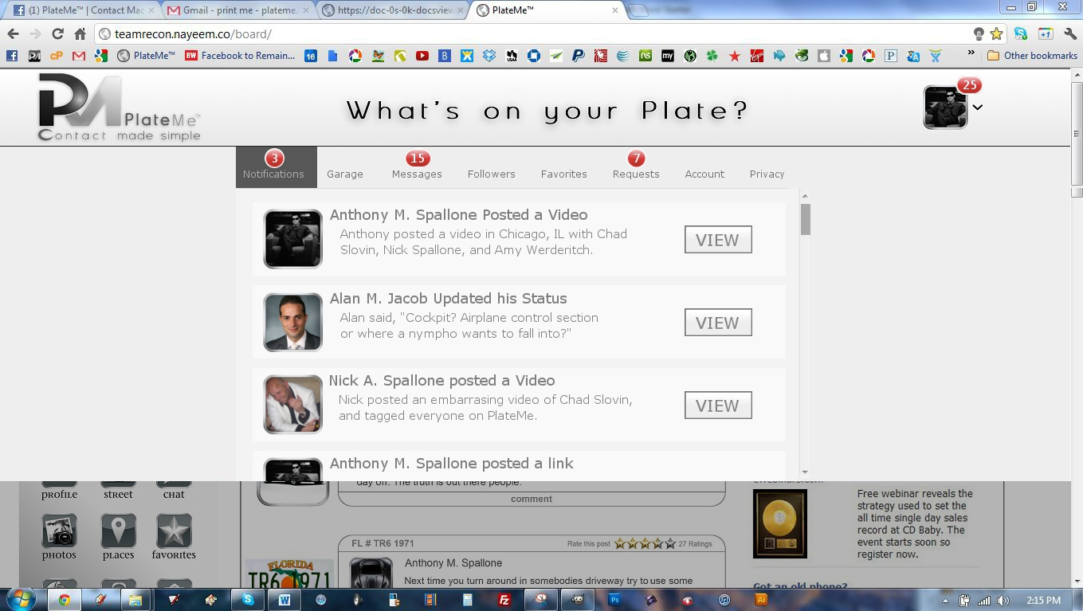**Drop Down Menu | Notifications**

The Notifications should appear as they do above.

1. A red bubble with the number of total notifications appears over the top right corner of the header profile picture.
2. A red bubble with the number of notifications appears over the menu names within the drop down menu.
   1. Notifications
   2. Garage
      1. If an item in your garage has a notification the red dot will tell you how many notification are on the total plate number
         1. Within the garage the number of notifications for each item will be displayed to the left of each plate in the red dot.
3. If a notifications has been viewed the notification sub box will be a few shades darker than the notifications that have not been viewed.
4. Clicking “View” brings the user to the page and location of the post and highlights it for a second by shading the post darker and lighter.
5. Remove “horizontal” scroll bar.

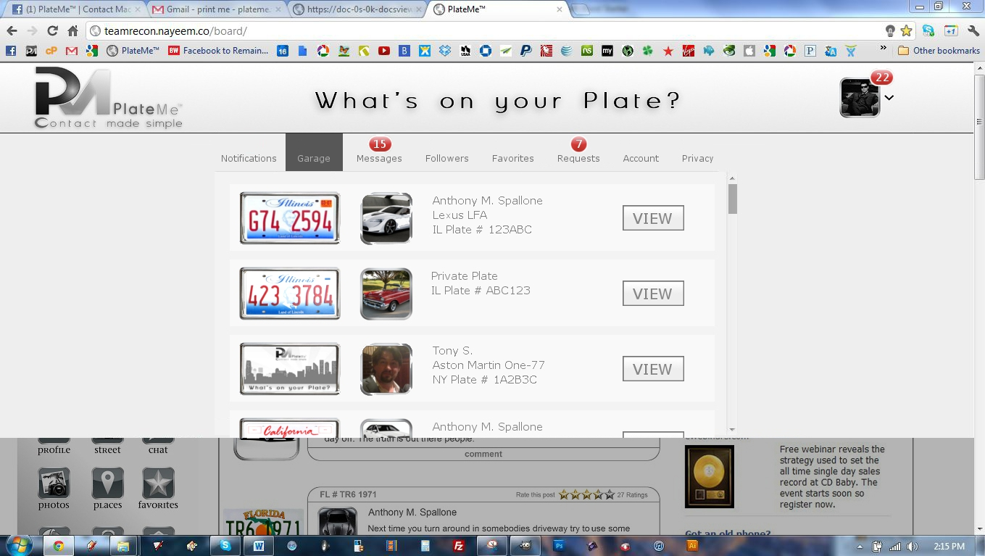

**Drop Down Menu | Garage**

The Garage should appear as it does above.

1. The Plate with Plate Number on the far Left (Notifications should appear to the left of the plates)
2. The Profile Picture that goes with the plate to the right of the Plate.
3. Information tied to the plate to the right of the profile picture
   1. Name
   2. Make Model
   3. Plate Number
4. Where it says “View” should say “Switch”
   1. When the user clicks “Switch” their current profile should change to the one they switched to. The Profile picture in the header and left sidebar should change to the profile picture associated with the chosen plate.
5. Remove “horizontal” scroll bar.

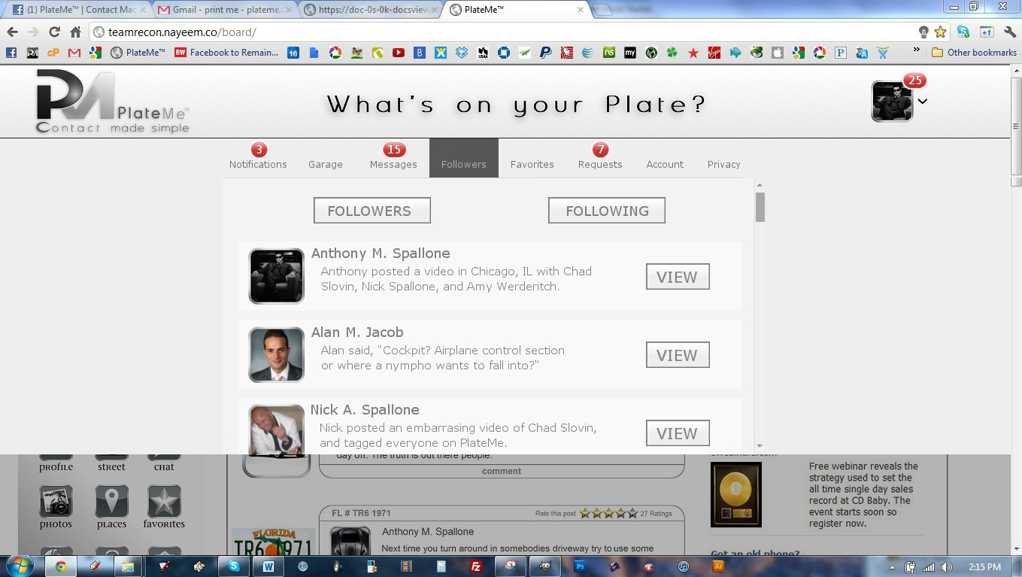

**Drop Down Menu | Followers**

The Followers Box should appear as it does above.

1. Here you can view who you are following and who is following you.
2. Within this box you can choose to stop certain followers from following you
3. Within this box you can choose to stop following certain users
4. Next to followers you can see their last post and where they posted.
5. Click view to see their last post
6. Click their profile photo to view their profile

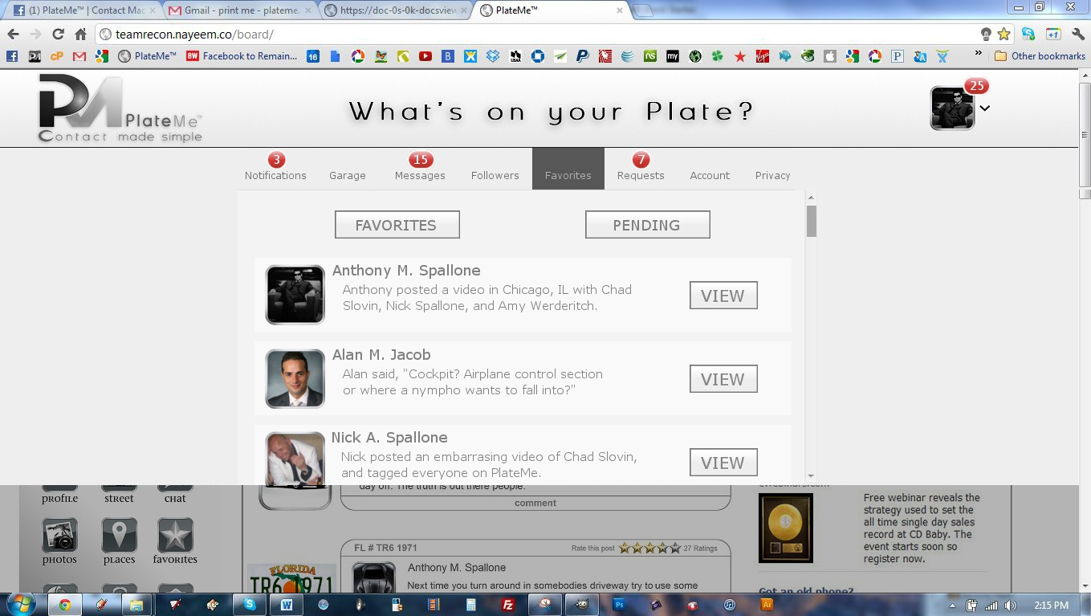

**Drop Down Menu | Favorites**

The Followers Box should appear as it does above.

1. Here you can view your favorites and pending favorites
   1. Pending Favorites
      1. Favorite Requests you sent out that have not been confirmed by the user.
      2. Favorite Requests sent to you that you have not confirmed
2. Within this box you can choose to remove from favorites
3. Next to favorites profile picture you can see their last post and where they posted.
4. Click view to see their last post
5. Click their profile photo to view their profile

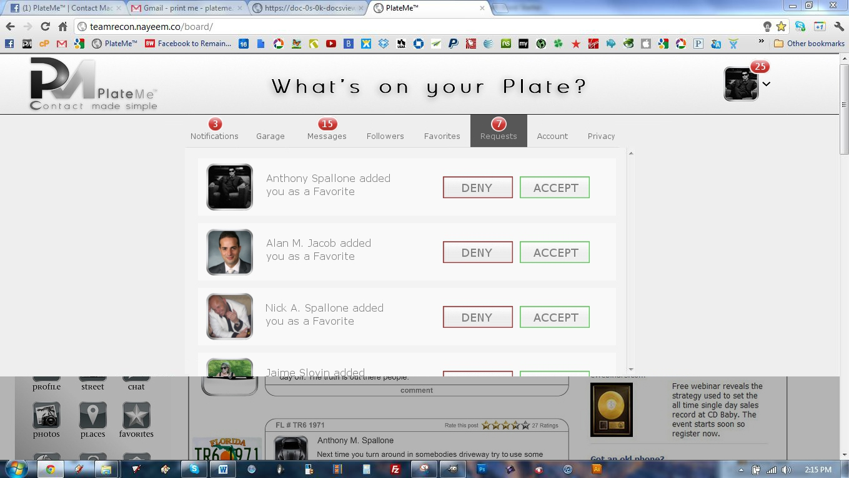

**Drop Down Menu | Requests**

The Requests Box should appear as it does above.

1. Here will show all requests types to accept or deny
   1. Photo Tags
   2. Location Tags
   3. Video Tags
   4. Audio Tags
   5. Favorite Requests

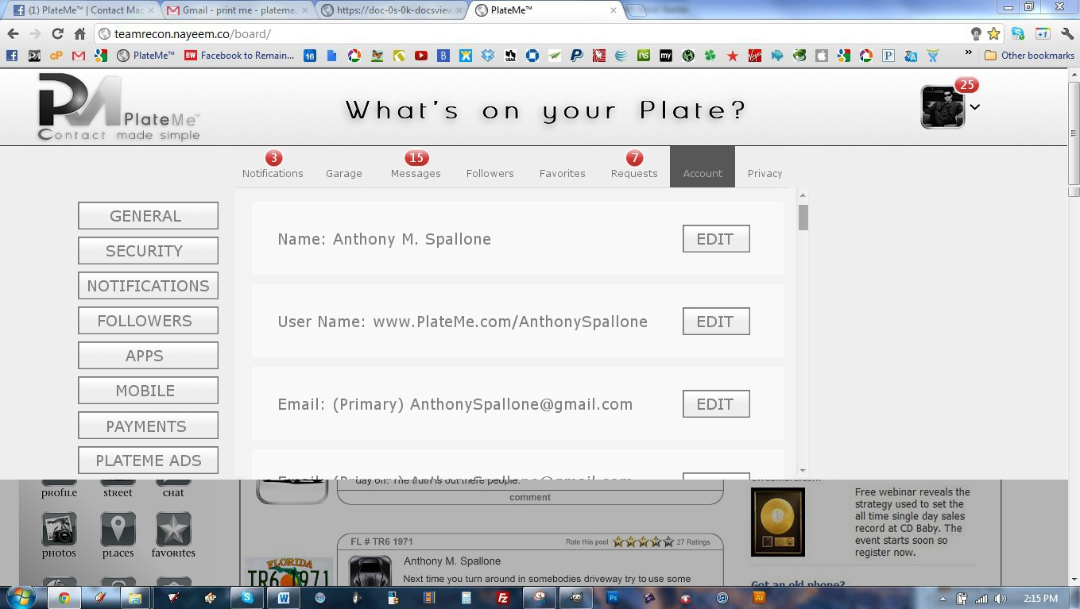

**Drop Down Menu | Account Settings**

The Account Settings should appear as they do above.

**General Account Settings:**

1. Name - Anthony Spallone - Edit
2. Username - <http://www.PlateMe.com/AnthonySpallone> - Edit
3. Email - Primary: anthonyspallone@gmail.com - Edit
4. Password - Password never changed. - Edit
5. Linked Accounts - You have 0 linked accounts - Edit
6. Language - English (US) - Edit
7. Download a copy of your PlateMe data.

**Security Settings:**

1. Security Question - Edit
   1. Setting a security question will help us identify you.
2. Secure Browsing - Edit
   1. Secure browsing is currently disabled.
3. Login Notifications - Edit
   1. Login notifications are disabled.
4. Login Approvals - Edit
   1. Approval is not required when logging in from an unrecognized device.
5. App Passwords - Edit
   1. You haven't created App Passwords.
6. Recognized Devices - Edit
   1. No recognized devices.
7. Active Sessions - Edit
   1. Logged in from Unknown Location and 6 other locations.
8. Deactivate your account.
   1. Deactivating your account make all of your current posts and information public.

**Notifications Settings:**

1. Send me important updates and summary emails instead of individual notification emails
2. We send notifications whenever actions are taken on Facebook that involve you. You can change which applications and features can send you notifications.
   1. Notifications are being sent to anthonyspallone@gmail.com (email).
3. Edit Notifications  
   1. Basic
      1. Get Notifications When Someone
         1. Sends you a message
         2. Adds you as a favorite
         3. Confirms a favorite request
         4. Posts on your Wall
         5. Has a birthday coming up (weekly message)
         6. Suggests a favorite you might know
         7. Adds a favorite you suggested
         8. Joins PlateMe after your invite
         9. Tags you on their profile
         10. Tags you in a post
         11. Mentions you in a comment
         12. Comments on a post you were tagged in
         13. Follows your public updates
         14. Posts content (Following Only)
         15. Says you are with them in a post
         16. Rates your post
         17. Rates a post you're tagged in
   2. Photos
      1. Get Notifications When Someone
         1. Tags you in a photo
         2. Tags one of your photos
         3. Comments on your photos
         4. Comments on a photo of you
         5. Comments after you in a photo
         6. When you upload a photo via email
         7. Comments on your photo albums
         8. Comments after you on a photo album
   3. Events
      1. Get Notifications When Someone
         1. Invites you to an event
         2. Changes the date or time of an event
         3. Updates an event you've joined
         4. Cancels an event
         5. Makes you an event admin
         6. Posts on the wall of an event you admin
         7. Posts on the wall of an event you've joined
         8. Changes the name of an event you're invited to
         9. Changes the photo of an event
   4. Links
      1. Notifications When Someone
         1. Comments on your links
         2. Comments after you on a link
         3. Shares something you posted
   5. Video
      1. Notifications When Someone
         1. Tags you in a video
         2. Tags one of your videos
         3. Comments on your videos
         4. Comments on a video of you
         5. Comments after you in a video
   6. New Feed
      1. Notifications When Someone
         1. Comments on a story on your Wall
         2. Comments after you on a Wall story
   7. Other updates from PlateMe
      1. Notifications When Someone
         1. Updates about your Favorites since you logged in
         2. Updates about PlateMe product news
         3. Invitations to participate in research about PlateMe
         4. Weekly website updates for admins
         5. Favorite activity on PlateMe
   8. PlateMe Funds
      1. Credits you've purchased
      2. Pending order has been completed

**Followers Settings:**

1. Allow Followers
2. Followers will receive your public posts and will not be added as favorites. You can have broader conversations about public topics and keep personal updates for friends.
   1. Learn more.
3. Followers Comments - Edit
4. Who can comment on your public posts:
   1. No Body
   2. Followers
   3. Following
   4. Favorites
   5. Favorites of Favorites
   6. Everybody
5. Followers Notifications - Edit
   1. Notify me about followers and comments from: Favorites of Favorites
6. Username - Edit
   1. http://www.PlateMe.com/AnthonySpallone
7. Twitter - Edit
   1. Connect a Twitter account
8. Facebook - Edit
   1. Connect a Facebook account
9. LinkedIn - Edit
   1. Connect a LinkedIn account
10. Want to know what Followers can see? View your public profile.

**Apps Settings:**

1. Go to App Store
2. View My Apps
   1. App – Edit – Remove – Suggest to Friend

**Mobile Settings:**

1. Your phones:
   1. 1 630.640.9221 · Remove
   2. + Add another mobile phone number
2. Your registered phone is not activated for text messaging.
   1. Activate Now
3. Learn more about using PlateMe on your phone at Facebook Mobile.

**Payments Settings:**

1. Buy Apps Faster by adding funds to your PlateMe Account
2. Funds Balance - $123.32 - Add More
   1. You have $123.32 for purchasing premium items, apps and playing games.
3. Funds Added – View History
   1. View your recently added PlateMe Funds.
4. Payment Methods - Manage
   1. You do not have any payment methods saved.
      1. Add PayPal Account
      2. Add Google Wallets
      3. Add Credit Card
5. Preferred Currency - Edit
   1. Currencies will be shown and purchased as US Dollar.
6. Learn more about PlateMe Funds.

**PlateMe Ads:**

1. Ads shown by third parties
   1. PlateMe does not give third party applications or ad networks the right to use your name or picture in ads. If we allow this in the future, the setting you choose will determine how your information is used.
   2. You may see social context on third party sites, including in ads, through PlateMe social plugins. Although social plugins enable you to have a social experience on a third party site, PlateMe does not share your information with the third party sites hosting the social plugins. Learn more about social plugins.
2. Edit third party ad settings
3. Ads and friends
4. Everyone wants to know what their friends like. That's why we pair ads and friends—an easy way to find products and services you're interested in, based on what your friends share and like. Learn more about social ads.
5. Here are the facts:
   1. Social ads show an advertiser's message alongside actions you have taken, such as liking a Page
   2. Your privacy settings apply to social ads
   3. We don't sell your information to advertisers
   4. Only confirmed friends can see your actions alongside an ad
   5. If a photo is used, it is your profile photo and not from your photo albums
6. Edit social ads setting

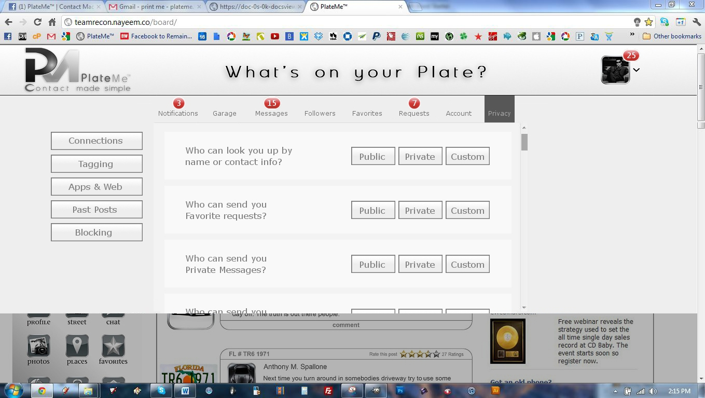

**Drop Down Menu | Privacy Settings**

The Privacy Settings should appear as they do above.

**Connections Settings:**

To edit your followers settings, go to your followers tab.

1. Who can look you up using the email address or phone number you provided?
   1. Everyone
   2. Favorites of Favorites
   3. Favorites
2. Who can send you friend requests?
   1. Everyone
   2. Favorites of Favorites
3. Who can send you PlateMe messages?
   1. Everyone
   2. Favorites of Favorites
   3. Favorites
4. Learn more

**Tagging & Posts:**

1. Who can post on your profile?
   1. Everyone
   2. Favorites of Favorites
   3. Favorites
   4. Select People Can
   5. Select People Can Not
   6. Nobody
2. Review posts Who can see what others post on your profile?
   1. Everyone
   2. Favorites of Favorites
   3. Favorites
   4. Select People Can
   5. Select People Can Not
   6. Nobody
3. Review posts Who can see posts that appear on your profile because you've been tagged?
   1. Everyone
   2. Favorites of Favorites
   3. Favorites
   4. Select People Can
   5. Select People Can Not
   6. Nobody
4. Review posts friends tag you in before they appear on your profile
   1. Everyone
   2. Favorites of Favorites
   3. Favorites
   4. Select People Can
   5. Select People Can Not
   6. Nobody
5. Review tags friends add to your own posts on PlateMe
   1. Everyone
   2. Favorites of Favorites
   3. Favorites
   4. Select People Can
   5. Select People Can Not
   6. Nobody
6. Who sees tag suggestions when photos that look like you are uploaded?
   1. Everyone
   2. Favorites of Favorites
   3. Favorites
   4. Select People Can
   5. Select People Can Not
   6. Nobody
7. Allow friends to check you in with mobile Places
   1. Everyone
   2. Favorites of Favorites
   3. Favorites
   4. Select People Can
   5. Select People Can Not
   6. Nobody

**Apps, Games and Websites Settings:**

1. On PlateMe, your name, profile picture, gender, networks, username and user id (account number) are always publicly available, including to apps (Learn Why). Also, by default, apps have access to your favorites list and any information you choose to make public.
   1. Edit your settings to control what's shared with apps, games, and websites by you and others you share with:
2. Apps you use
   1. You're using 152 apps, games and websites, most recently:
      1. March 21
         1. GNews-Google News
         2. Causes
         3. TradeFields - Stock Market Simulator
      2. March 19
         1. Texas HoldEm Poker
      3. March 18
         1. Pandora
3. Remove unwanted or spammy apps.
   1. Turn off all apps.
   2. Edit Settings
      1. How people bring your info to apps
         1. they use People who can see your info can bring it with them when they use apps. Use this setting to control the categories of information people can bring with them.
            1. Edit Settings
4. Instant personalization
   1. Lets you see relevant information about your favorites the moment you arrive on select partner websites.
      1. Edit Settings
5. Public search
   1. Show a preview of your PlateMe Profile when people look for you using a search engine.
6. Edit Settings

**Past Posts:**

1. Limit The Audience for Old Posts on Your Profile
   1. You also have the option to individually change the audience of your posts. Just go to the post you want to change and choose a different audience.
   2. Learn about changing old posts

**Blocking:**

1. Add friends to your Restricted list
   1. When you add favorites to your Restricted list they can only see the information and posts that you make public. PlateMe does not notify your friends when you add them to your Restricted list.
      1. Edit List.
2. Block users
   1. Once you block someone, that person can no longer be your favorite on PlateMe or interact with you (except within apps and games you both use and groups you are both a member of).
   2. Block by Name:
   3. Block by Email:
3. Blocked Users
   1. Jon Dough - Unblock
   2. Harry Sally - Unblock
4. Block app invites
   1. Once you block app invites from someone, you'll automatically ignore future app requests from that friend. To block invites from a specific friend, click the "Ignore All Invites From This Friend" link under your latest request.
   2. Block invites from:
      1. Block by Name:
      2. Block by Email:
5. Block event invites
   1. Once you block event invites from someone, you'll automatically ignore future event requests from that friend.
   2. Block invites from:
      1. Block by Name:
      2. Block by Email:
6. Block apps
   1. Once you block an app, it can no longer contact you or get non-public information about you through PlateMe. Learn More.
   2. Blocked Apps
      1. Mafia Wars
      2. Farmville

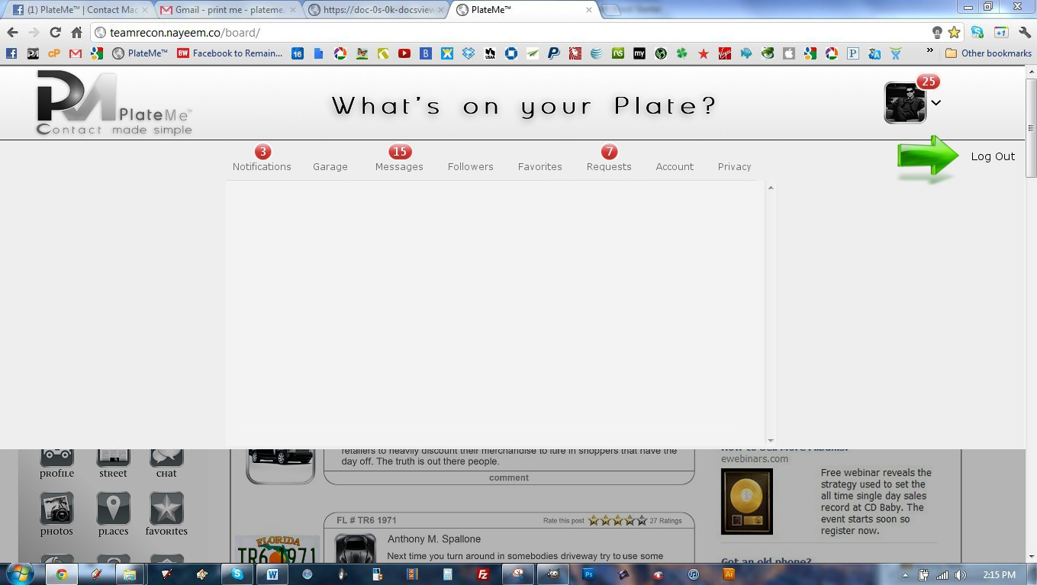

**Drop Down Menu | Log Out**

Put Log Out Button here (Do not put a green arrow)

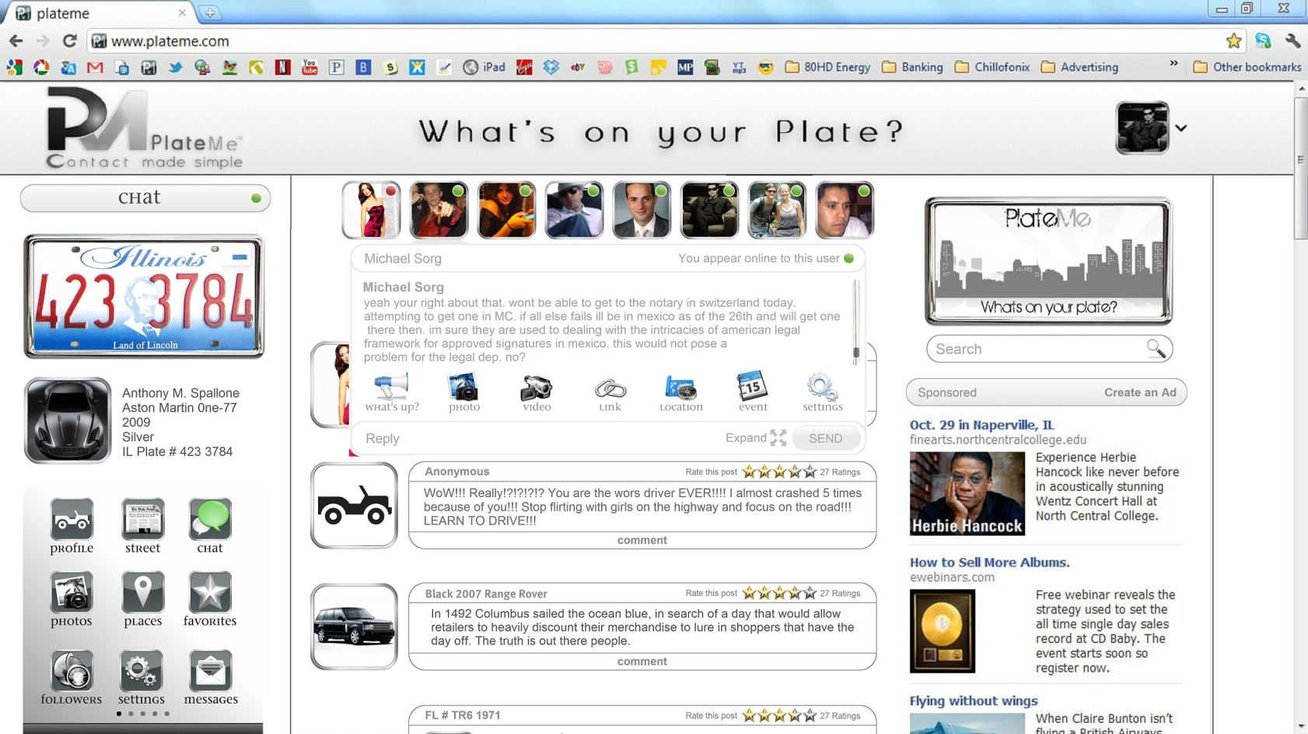

**Drop Down | Chat**

1. The Chat Feature should look “Identical” a trace over of the page above. All sizes and dimensions must look as they do above.
2. Chat Features include all the same features as posts:
   1. What’s Up | Written Posts
   2. Photo Posts
   3. Video Posts | Webcam and Uploads
   4. Links | With a Preview Display of the Link
   5. Location | Share Location | Show a Locations
   6. Events | Make an Event | Invite to Event
   7. Settings | Alternate File Shares i.e. Documents, PDF, Word, Screen Share

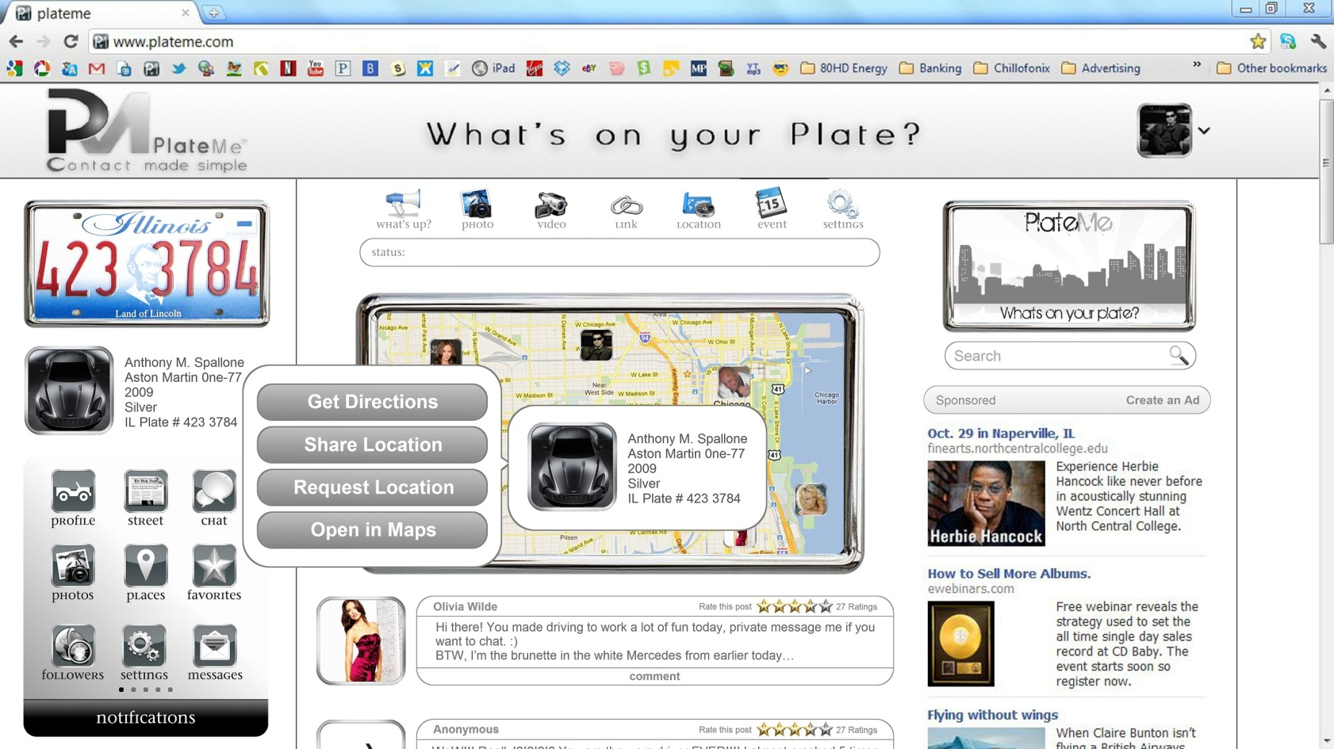

**GPS | Maps**

1. When the GPS Button is hit the all of the favorites last location will appear.
2. Click on a user’s picture to see all GPS Features
   1. Get Directions
      1. Click this to get directions form your current location or an alternate address.
   2. Share Location
      1. Click a user’s picture and click share location to notify that user of your current location.
   3. Request Location
      1. Click a user’s picture and click request location to get the most “live” location of this user.
   4. Open in Maps
      1. Open in Google Maps with all of the Google Maps Features but do not leave PlateMe

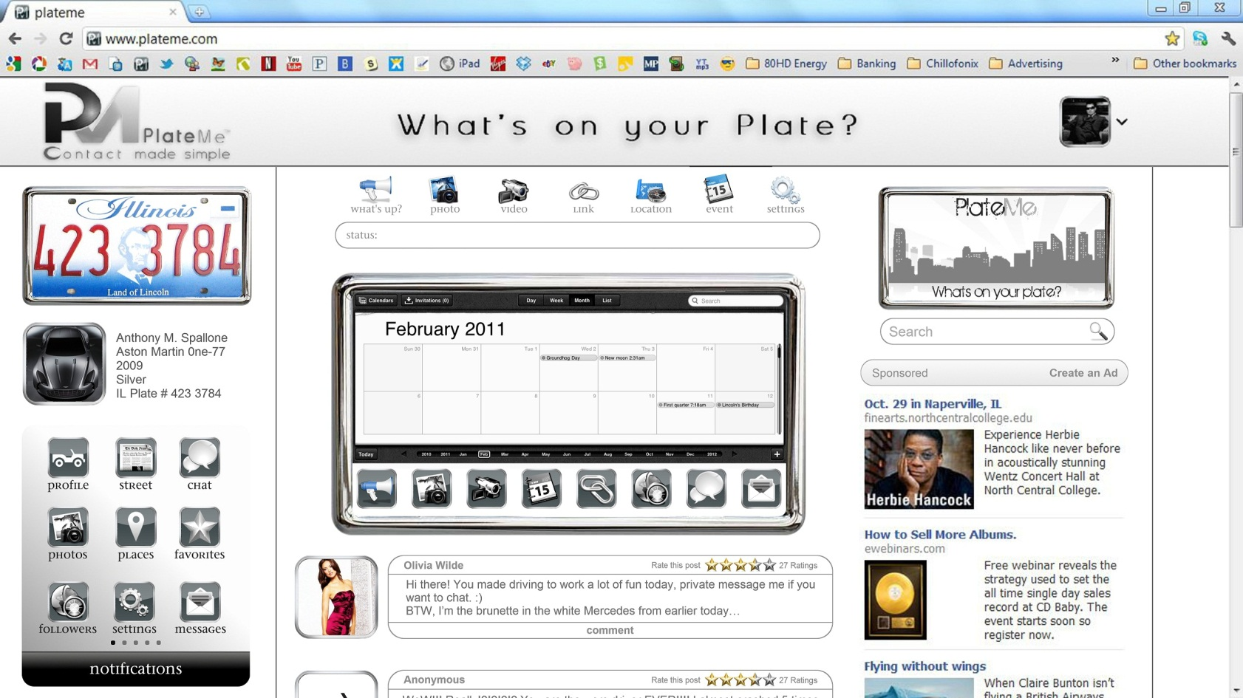

**Time MachineTM**

1. When the Time Machine Button is hit have this appear.
2. The Time Machine is a tool that allows users to find past posts easily and quickly.
   1. When a Day / Month / Year is picked the user has the ability to search by post type:
      1. Status Update
      2. Photo
      3. Video
      4. Event
      5. Link
      6. Location
      7. Chat
      8. Private Message
3. The Time Machine is also a tool that allows users to make Future Posts, by simply selecting a Time / Day / Month / Year, after a date and time is selected they can make various post types that will not be visible until their selected date:
   1. Post Types
      1. Status Update
      2. Photo
      3. Video
      4. Event
      5. Link
      6. Location
      7. Chat
      8. Private Message

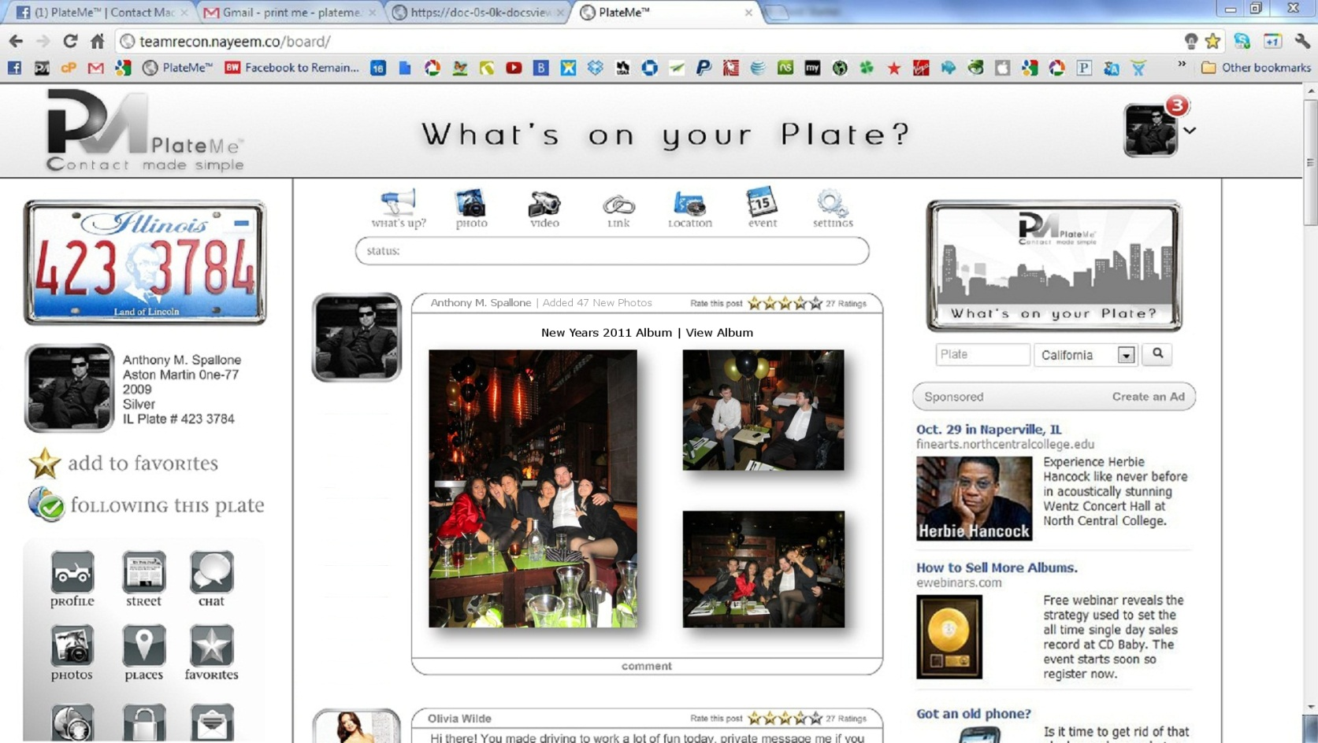

**News Feed | Photos**

1. When a user makes a post display 1 large image to the left and 2 small images to the right as shown above.
   1. Insert shadow effect behind Photos
2. Display the Album Title then a link to view all album
   1. Album Title | View Album
3. Allow Comment on Album, Allow users to share album

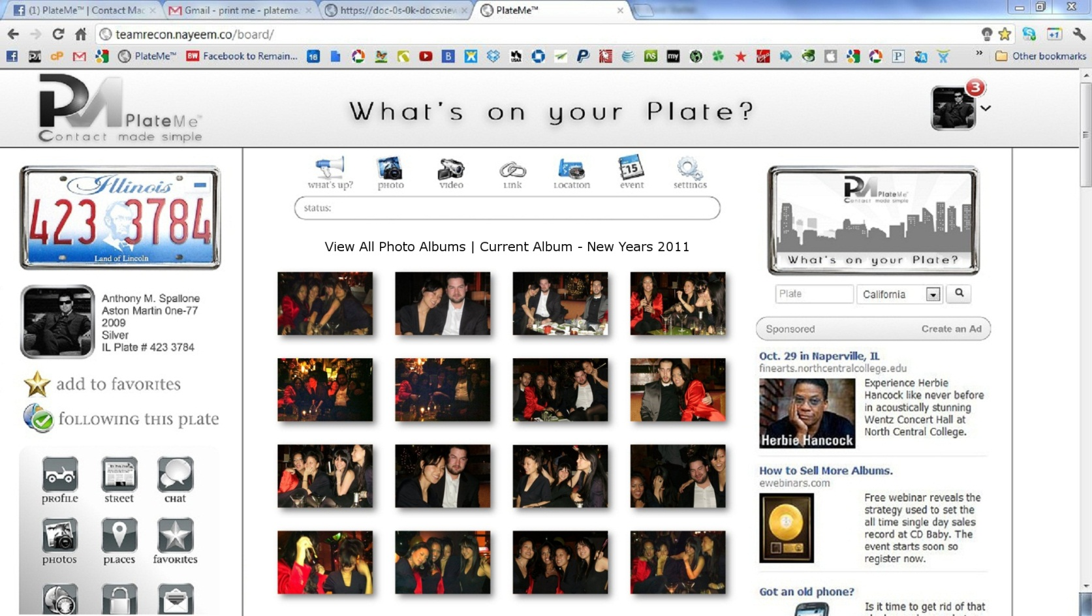

**Albums | Photos**

1. Display Albums 4 Photos Wide
2. Insert Shadow effect behind all photos
3. Allow Comments on photos, allow users to share individual photos

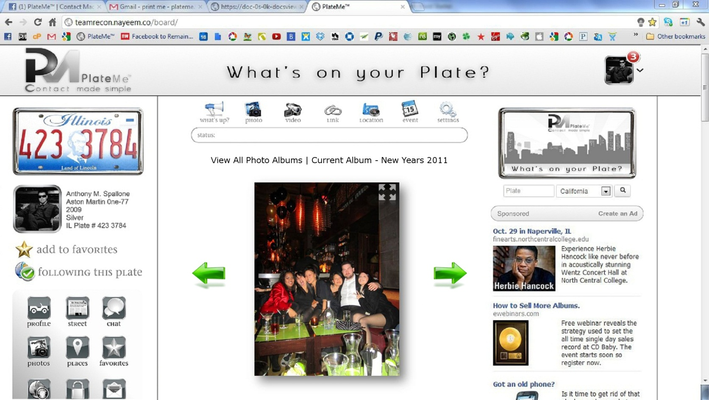

**Albums | Photos Medium Display**

1. Click any image on PlateMe and this pops up
2. Have the ability to scroll through the album by clicking to the right or left side of the photo (Have the arrows appear on hover of left side of the photo or right)
3. Comments box below the photo with share options
4. The top right of the photo has a full screen feature, click that and see below

**News Feed | Photos Full Screen View**

1. Have the ability to scroll through the album by clicking to the right or left side of the photo (Have the arrows appear on hover of left side of the photo or right)

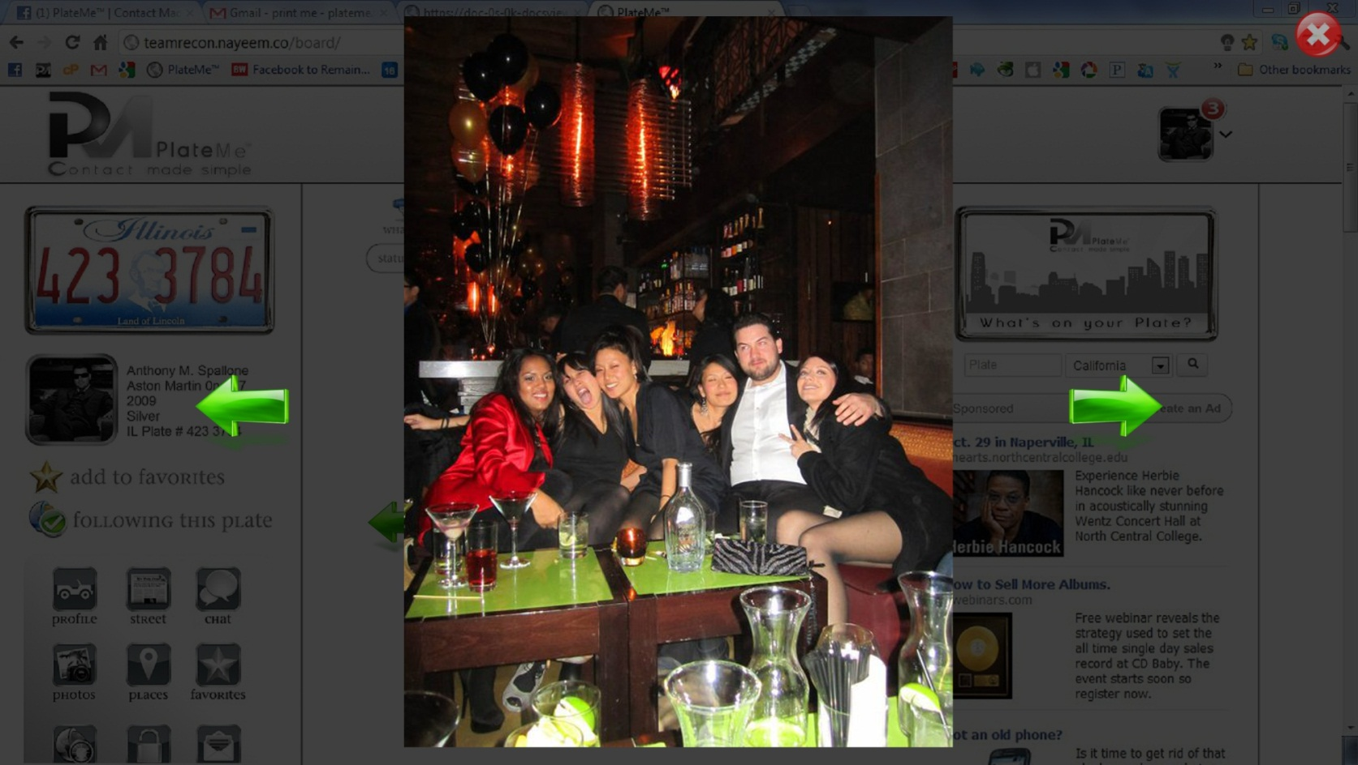

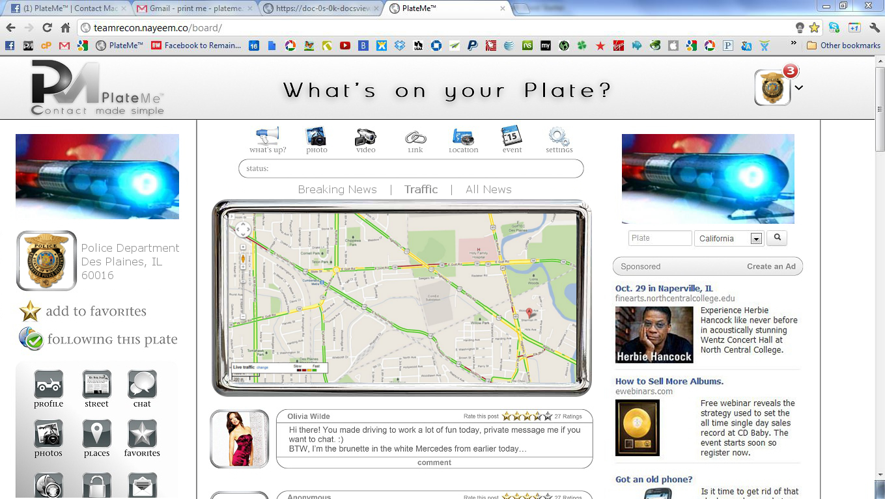

**Various Page Types | Local News**

1. The Example above shows a user searching for Local News
2. Local News Offers 3 types of News Feeds
   1. Breaking News
   2. Traffic
      1. Traffic Shown above shows current traffic
      2. You can get directions and plan trips from here
   3. All News

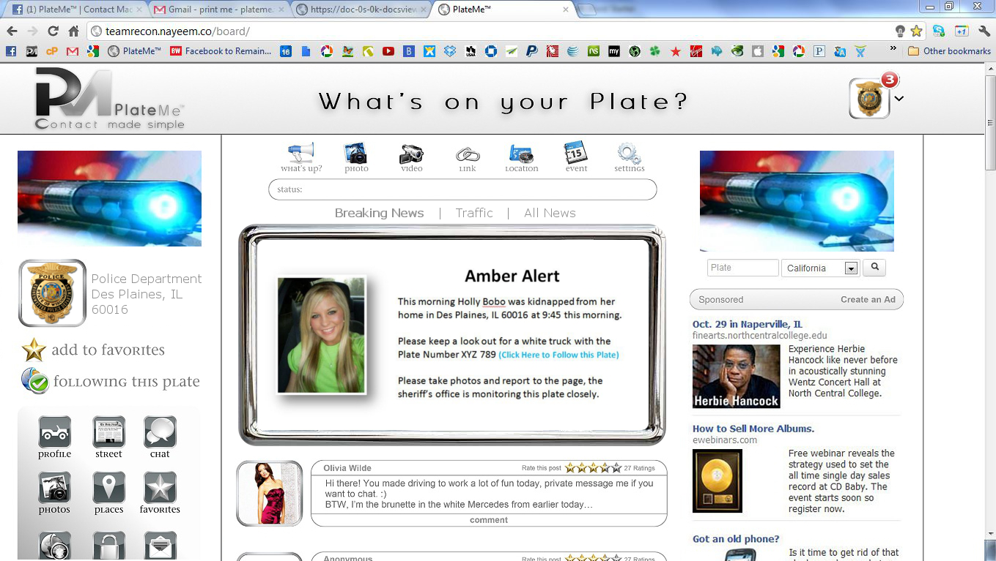

**Various Page Types | Local News Breaking News**

1. The Example above shows a user searching for Local News
2. Local News Offers 3 types of News Feeds
   1. Breaking News
      1. Breaking News Contains posts made by
         1. All Users
         2. Local Police
            1. Local Police have priority placement as shown above,

The local police (once verified) can put their posts in the Chrome frame that is always on the top of the page.

The Police have a “Public Safety” feature that allows them to make posts in the chrome fame on various accounts.

The example shown above displays an Amber alert with a plate number in question.

The police have the ability to post this Chrome Frame Alert on the Plate of question and keep it there until the case is resolved, see below. For details

* + - 1. News Companies
  1. Traffic

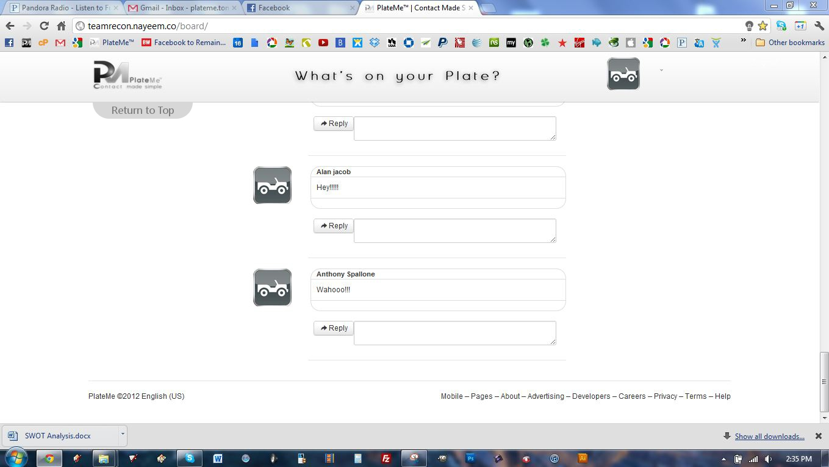

**Various Functions | Return to Top**

* + 1. This is a one click feature that allows users to return to the top of the page with one click.
       1. It is frustrating when scrolling down very far in a page and needing to go to the top,
          1. This button allows for users to return to the top of the page from anywhere.

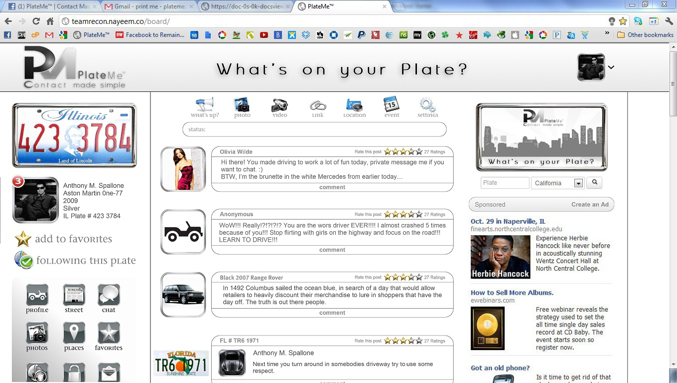

**Various Functions | Comments & Posts**

1. Comments and Posts:
   1. Squared off Profile Picture in Chrome Frame to the Left of the comment box
   2. Comment box
      1. Name | Plate Number
      2. Star Rating
      3. Time Stamp
      4. Comment
      5. Share

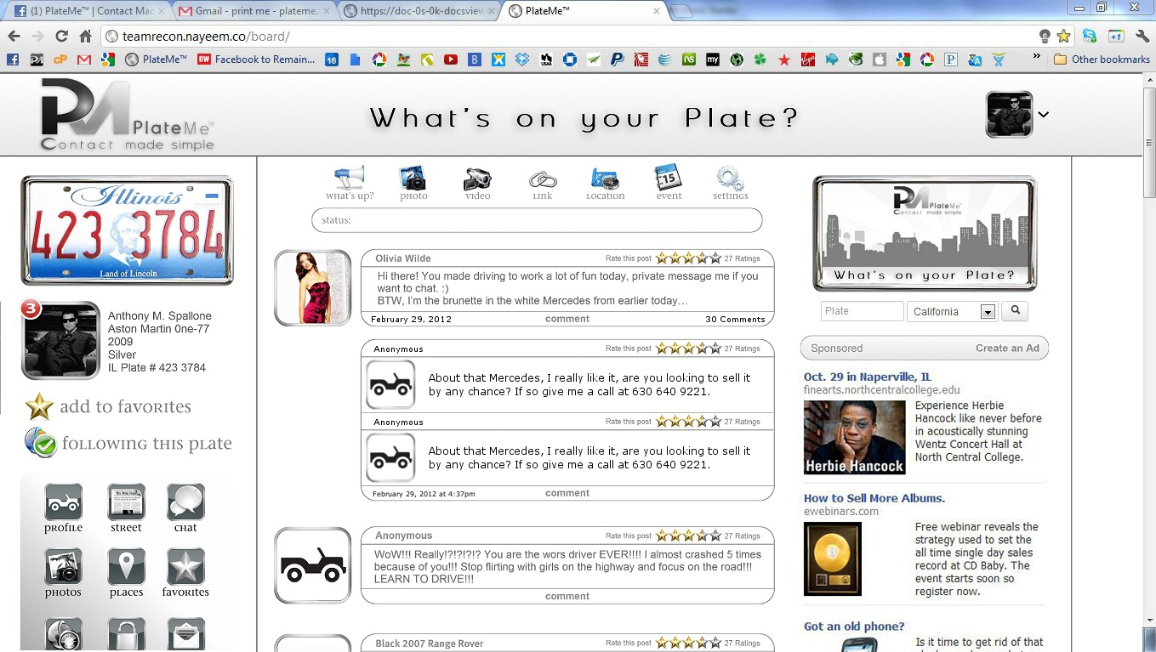

**Various Functions | Comments on Comments**

1. Comments on Comments:
   1. Squared off Profile Picture in Chrome Frame within the comment box
      1. Comment box
         1. Name | Plate Number
         2. Star Rating
         3. Time Stamp
         4. Comment
         5. Share

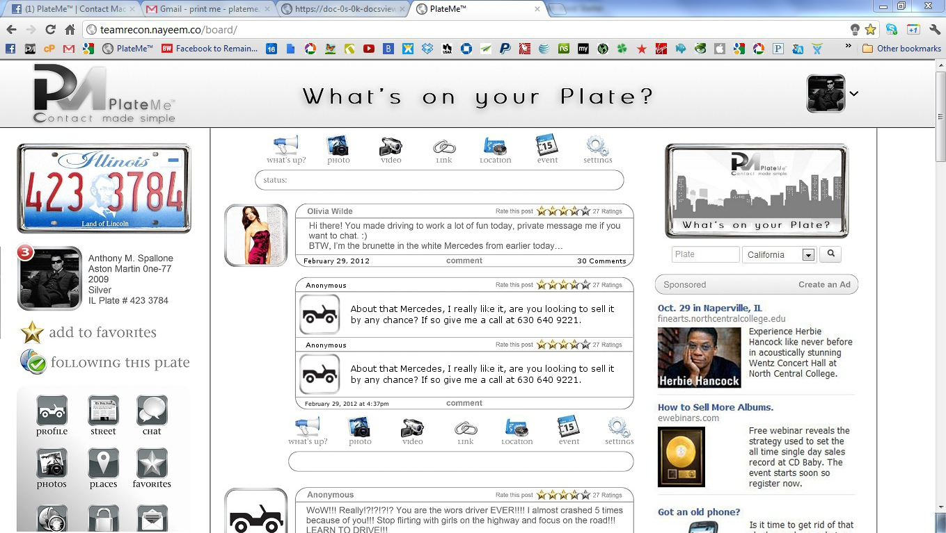**Various Functions | Commenting on Comments**

1. Commenting on Comments:
   1. When the “comment” button is hit a drop down menu pops up for the user to make their comments simple.
      1. When commenting on comments users can
         1. Post written updates
         2. Photos
         3. Videos (Webcam or upload)
         4. Links
         5. Location / GPS
         6. Events / Time Machine
            1. Create an event
            2. Post on a future date
         7. Settings
            1. Post publicly
            2. Post Privately
            3. Post as yourself
            4. Post as anonymous

**Various Functions | Commenting on Comments**

1. Commenting on Comments:
   1. When the “comment” button is hit a drop down menu pops up for the user to make their comments simple.
      1. When commenting on comments users can